Directions for template use. After opening file, Save As immediately to your own document name. Follow the sections as provided. The headings have been set in the Word Style Manager. Do not use Insert Table of Contents using the styles because it will not match up to the Lamar requirements. You will need to type that in manually.
TITLE OF DISSERTATION GOES HERE CENTERED

A Dissertation
Presented to
The Faculty of the College of Graduate Studies
Lamar University

In Partial Fulfillment
of the Requirements for the Degree
Doctor of Education in Educational Leadership
by
Student’s Name
Month and Year of Graduation (December 2016)
TITLE OF DISSERTATION
by
AUTHOR NAME
Approved:
_________________________________
Name of Chair
Dissertation Chair

_________________________________
Name of Committee Member
Committee Member

________________________________
Name of Committee Member
Committee Member

________________________________
Name of Committee Member
Committee Member

_________________________________
Brett Welch
Director, Doctoral Program

_________________________________
Diane Mason
Chair, Department of Educational Leadership

________________________________
Robert J. Spina
Dean, College of Education and Human Development

________________________________
William E. Harn
Dean, College of Graduate Studies

© 20XX by Student Name

No part of this work may be reproduced without permission except as indicated by the “Fair Use” clause of the copyright law. Passages, images, or ideas taken from this work must be properly credited in any written or published materials.

ABSTRACT
TITLE OF DISSERTATION
by
Student Name
The abstract must contain the following components: problem statement, research questions, brief information about sample, brief information about data collection and analysis, brief statement of findings and implications for practice.

ACKNOWLEDGEMENTS
I would like to express my appreciation….

Table of Contents
List of Figures iv
List of Tables v
Chapter Page
I Introduction to the Study 1
Background 1
Problem Statement 1
Theoretical Foundation 1
Statement of the Purpose and Research Questions 1
Rationale and Significance of the Study 1
Assumptions 1
Limitations and Delimitations 1
Definitions of Terms 1
Summary and Organization of the Study 2
II Review of the Literature 3
Individual Subheadings (Heading 2) 3
Heading 3 3
Heading 4 3
Summary 4
III Methodology 5
Research Questions and or Hypotheses 5
Research Design 5
Population/Participants 5
Instrumentation 5
Data Collection Procedures 5
Data Analysis 5
Summary 5
IV Findings or Analysis of Data 6
Use Subheadings as Appropriate 6
Summary 6
V Summary, Conclusions, Implications, and Recommendations 7
Summary of the Study 7
Conclusions 7
Implications for Practice 7
Recommendations for Future Research 7
Concluding Remarks 7
References 8
Appendices 9
Appendix A 10
Appendix B 11
Biographical Note 12

List of Figures
Figure Page
Figure 1 Title of Figure 7
Figure 2 Title of Figure 11
Figure 3 Title of Figure 24

List of Tables

Table Page
Table 1 Title of Table XX
Table 2 Title of Table

Chapter I
Introduction to the Study
Text goes here -

Background
Text goes here

Problem Statement
Text goes here

Theoretical Foundation
Text goes here

Statement of the Purpose and Research Questions
The central purpose for this dissertation … The following questions guided the research:
- Research question One
- Research question Two
Every succeeding chapter should include the purpose statement at the beginning stated in exactly the same way.

Rationale and Significance of the Study
Text goes here

Assumptions
Text goes here - Assumptions are those issues or items that are taken for granted relative to this study. An example would be: the study participants answered all of the interview questions openly and honestly.

Limitations and Delimitations
Begin this section with a cited definition of Limitations. Limitations are those factors that may affect the study and over which the researcher does not have control (CITE). This constrains generalizability of findings. For example, a study of English language acquisition among native Spanish speakers based on data from a truly representative sample of this group, would allow the researcher to make generalizations about this to the larger population even though they were not included in the study. However, this could not be generalized to other language speakers.
Delimitations are factors that may affect the study that are controlled by the researcher (CITE). For example, delimitation might be that the study included only those superintendents who had been serving in the same district for at least five years. The delimitations should reflect the criteria for participant selection discussed in Chapter III. The student will prepare a statement of purpose or intent that clearly sets out what is meant to be accomplished by the study but that also includes a declaration of what the study does not intend to cover and why.

Definitions of Terms
The relevant terms used in this research study are defined as follows:
- Term - Terms must be bulleted and grounded in the literature.
- Conceptual and/or operational definitions should be provided for terms unique to the study. In all cases, definitions should be grounded in appropriate research literature (not a dictionary!) and cited.

Summary and Organization of the Study
Chapter I and the other chapters usually conclude with a section that delineates the contents of the remaining chapters in the study.
Example: This dissertation is organized into five chapters, a bibliography, and appendices. In Chapter I, the researcher has introduced the study. In Chapter II, the literature is reviewed. The methodology is explained in Chapter III…

Chapter II
Review of the Literature
This chapter … At the end of the introductory paragraph, point out how the chapter is organized. The main topics that are identified should be Level 2 headings in the chapter.
Other points for attention as you write the literature review:
- Limit paragraph length to approximately 15 – 20 lines.
- One sentence is not a paragraph.
- Demonstrate to the reader a comprehensive grasp of the field and awareness of important recent substantive and methodological developments.
- Delineate the “jumping off place” for your study. How will this study refine, revise, or extend what is now known?
- Avoid statements which imply that little has been done in the area or that what has been done is too extensive to permit easy summary.
- Avoid excessive use of quotations. These should only be used when the quoted material is stated in a unique way and can be inserted without breaking the continuity of the writing.
- Be sure that the literature review covers topics related to all research questions.
- References cited should be as recent as possible, preferably within 5 years, unless the student is citing seminal research or providing a historical framework.

Individual Subheadings (Heading 2)
(will appear next for each topic covered)

Heading 3.

Heading 4.

Heading 5.

Summary
Text goes here - the chapter will conclude with a brief summary that directs the reader to the following chapters. For example, In Chapter II, the researcher has reviewed the literature. The methodology is presented in Chapter III. In Chapter IV, the findings are presented. A summary of the study, conclusions, implications for practice, and recommendations for further study are discussed in Chapter V.

Chapter III
Methodology
Text goes here… The purpose of this chapter is to provide detailed information about the study. Understanding the nature of the design is critical to judging the trustworthiness of the research; therefore, this section must be linked to the previous two chapters in a logical and meaningful way. After the proposal has been defended and the study completed, this chapter will need to be updated with accurate demographic information.
Repeat what the study is all about using the purpose statement as it was stated in Chapters 1 and 2. Offer the reader a brief overview of the design. Detail will be provided in the following sections. Do not use a heading for this introductory paragraph. Chapter III will differ for qualitative and quantitative dissertations. Quantitative are in parentheses.

Purpose of the Study and Research Questions (Quant -– Purpose of the Study and Research Questions and/or Hypotheses)
This study…

Research Design
Text goes here

The Participants and or the Setting (Quant - Population/Participants)
Text goes here - It is in this section that the “who” and the “where” of the research is detailed and a rationale for those choices offered. Some chairs prefer that this subsection is divided into two separate topics.

Instrumentation (Quantitative only)
Text goes here

Data Collection (Quant - Data Collection Procedures)
Text goes here

Treatment of the Data (Quant - Data Analysis)
Text goes here

Provisions of Trustworthiness (Qualitative only)

Epoché
The Epoché should go here for qualitative dissertations. See Creswell text for definition.

(Sample of a Figure. Use 4 line spaces [two double spaced lines] above and below)
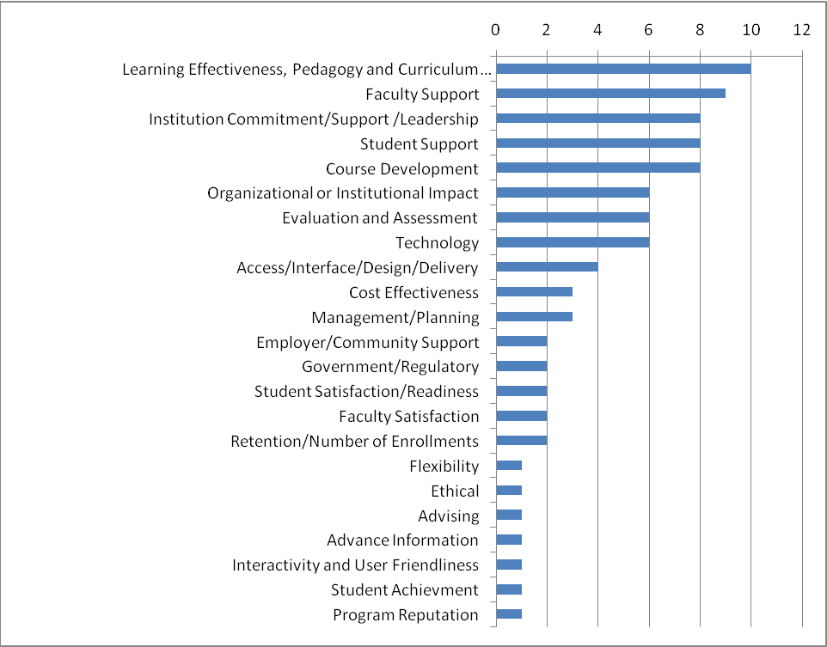
Figure 1. Quality themes of online education from the literature review.

Example table below. Use 4 line spaces [two double spaced lines] above and below each table…

Table 1 (SAMPLE)
Eight Generic Steps for Performance Excellence (Eggleston et al., 2007)
Key Steps for Establishing an Institutional Performance Excellence Model
- Identify and assemble a small (approximately ten members) cross-functional team to draft the strategic plan.
- Identify at least three, but no more than five, strategic planning priority goals.
- Identify indicators of performance objectives for each strategic planning priority goal.
- Identify at least one institutional measure for each key performance indicator.
- Establish targets for each measure (both long and short term).
- Create multi-level actions that deploy the plan.
- Track results monthly.
- Evaluate the plan at the conclusion of the academic year.

Summary
This chapter presented…

Chapter IV
Findings or Analysis of Data
Text goes here. Some qualitative dissertations will have several chapters to present findings, such as in narrative dissertations. In this case, the narrative chapters would become Chapter’s IV, V, VI, VII, etc. Then the narrative chapters would be followed by a Findings chapter called Narrative Analysis – this is where the narrative chapters are analyzed.

Use Subheadings as Appropriate
Text goes here

Summary
This chapter presented…

Chapter V
Summary, Conclusions, Implications, and Recommendations
Text goes here

Summary of the Study
This study…

Brief overview of the problem. Text goes here.

Purpose statement and research questions. Text goes here.

Review of the study design. (sample, data collection and data analysis techniques used).

Summary of major findings – usually organized by research questions. Text goes here.

Conclusions
Text goes here

Implications for Practice
Text goes here

Recommendations for Future Research
Text goes here

Concluding Remarks
This chapter presented…
References
Last Name, F. (year). Etc….

Appendices

Appendix A Title (do not put page numbers for each of these on this page)
Appendix B Title

Appendix A
IRB Informed Consent Approval

Biographical Note
This paragraph should provide a brief biographical note about the author.

Style manual delegation: Publication Manual of the American Psychological
Association, Sixth Edition
Typist: Jane Elizabeth Doe

