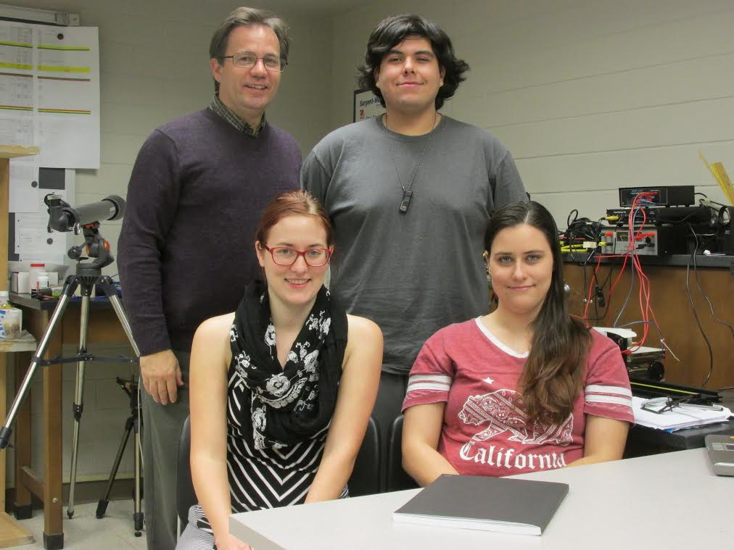
Figure 19: (Clockwise from top left) Dr. Bahrim, Zakary Noel, Suzanne Wheeler, and Keeley Fairchild

- On April 26, 2017 Joshua Kamienski, a Lamar physics alumnus, now physics teacher at Summer Creek HS visited a few members and discussed what it was like to teach physics at the High School level.
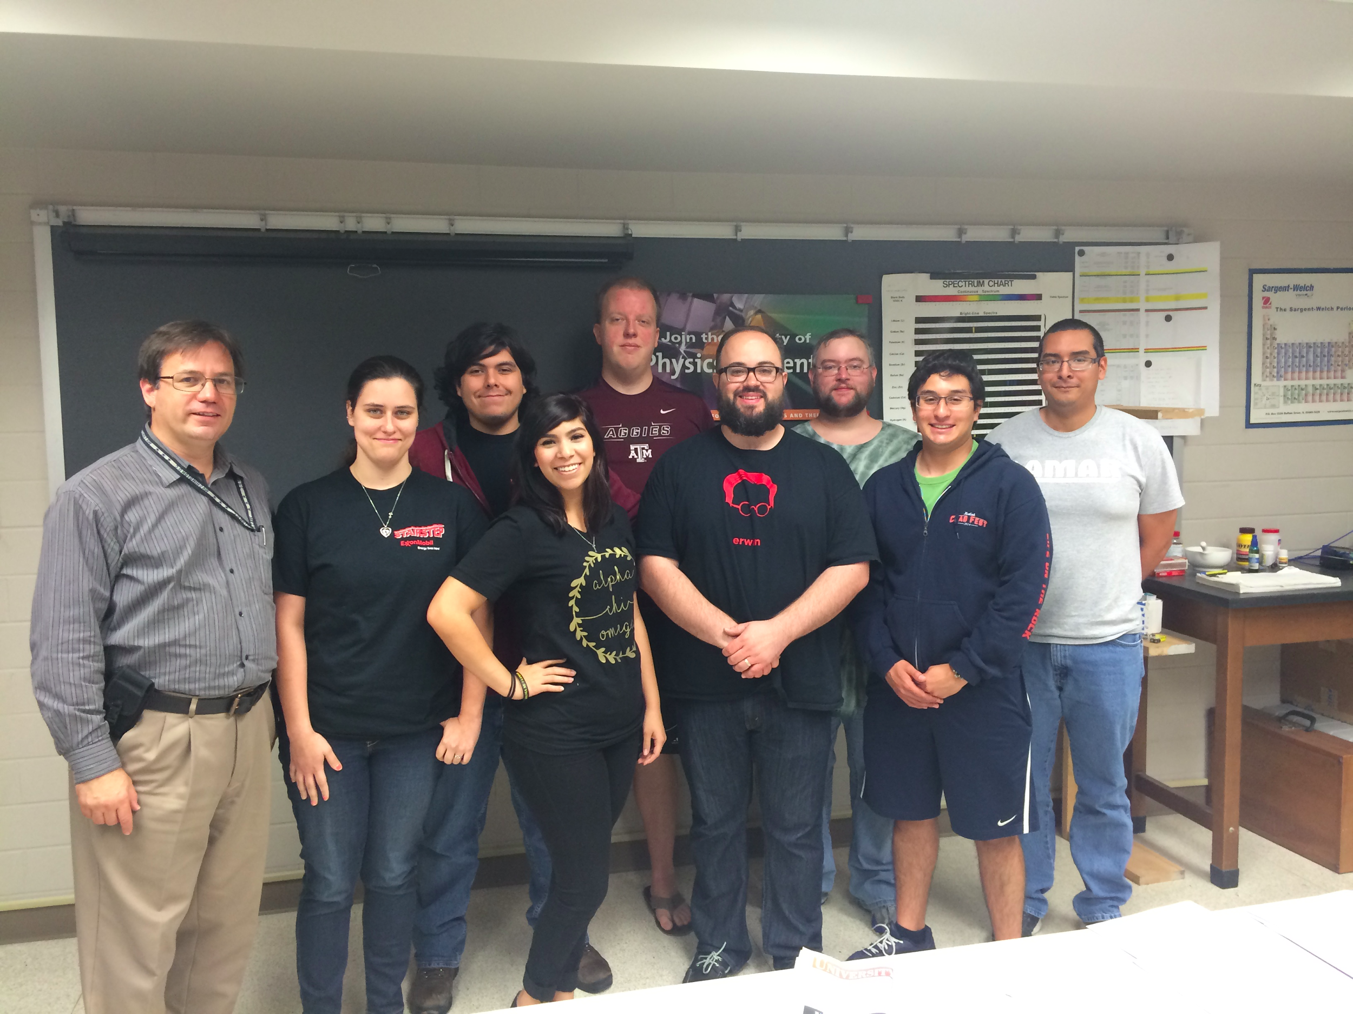
Figure 20: A group photo taken after Alumnus Joshua Kamienski speaks at Lamar University. (from left to right) Dr. Cristian Bahrim, Suzanne Wheeler, Zakary Noel, Gabrianna Escamilla, John Pickren, Alumnus Joshua Kamienski, Daniel Dove, Carlos Caballero, and Luis Romero.
- Our chapter is heavily involved in outreach programs that are focused toward local high schools. We have hosted demo presentations, career seminars, and talked personally with students from Central High School, Westbrook High School, Goose Creek High School, Kelly High School, Little Cypress-Mauriceville High School(LCM), and Port Neches-Groves High School (PNG). Our members typically will give brief PowerPoint presentations about physics as a career field and/or an academic pursuit. Members will also use High School Outreach Events as an opportunity to show students practical applications of simple physics using common demonstration materials. Often, members of our chapter are approached after a presentation or demonstration with plenty of questions. We are always happy to answer inquiries about the physics program specifically provided by our university with hopes that the students will choose to pursue a physics-related education. Much of the demography of incoming students at Lamar are engineering majors, so we aspire to steer them toward physics-oriented electives, such as Optics or Modern Physics for electrical engineers.
  - On Friday Nov 18, 2016, a group of 30 high school students from Central HS, a Beaumont ISD public school, visited campus and our chapter gave them a tour of the Physics building. The students were encouraged to step through the labs and view the equipment, see the posters that have been made for previous physics conferences, and let them view several undergraduate research projects firsthand. In addition, an interactive optical lab activity was set up that challenged the students to draw comparisons between the human eye and optical lenses. The students were instructed to use that information to form a specific image using an adjustable optical system.
  - On Friday, December 2nd, a group of 27 students also from Central HS were given a presentation by Suzanne Wheeler, John Pickren, and Zak Noel to help raise interest in physics and recruit for SPS. The students were gathered in a lecture hall and presented a number of demonstrations to help spark the high schoolers’ interest in physics-related studies. This also allowed the presenters to personally field questions about what they do as physics majors.
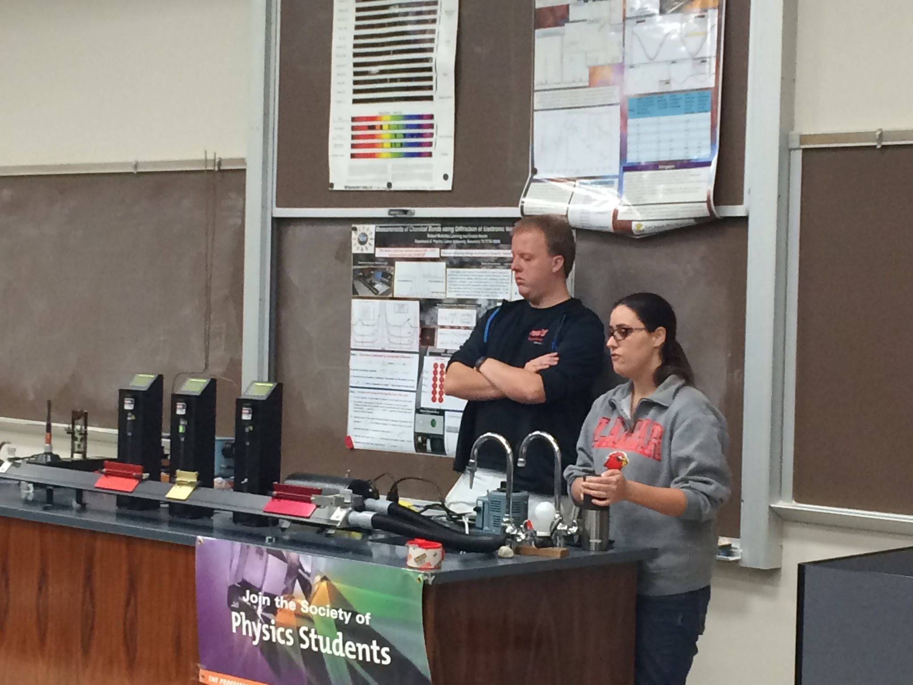
Figure 21: John Pickren and Suzanne Wheeler giving a presentation to high school students that visited campus on December 2, 2016.

  - On Friday, February 10th, Summer Creek Humble ISD visited Lamar University. SPS members were invited by the AVID coordinator to talk about career opportunities in physics in front of two groups of 20 students each.
  - On Tuesday, May 9th, 5 students from Kelley HS participated in a 1.5 visit to the physics department. They were taken to one of the labs and were given an opportunity to inquire about experiments with electricity, magnetism and optics requested by the instructor of physics, Mrs. Wagner. They were given a small complementary and hands-on experience to the materials taught in her class. All the student visitors were graduating seniors with interest to pursue studies in engineering fields.
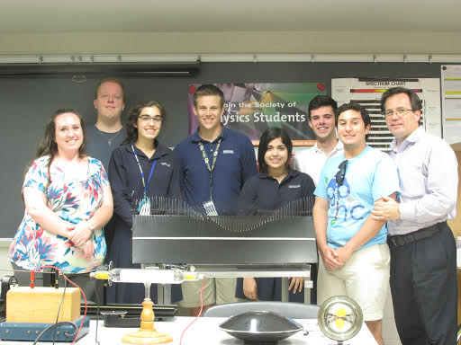
Figure 22: Kelly students with John, Carlos, and Dr. Bahrim.

- Five SPS members graduated during May 12-13, 2017 [4] [5]:
  - John Pickren graduated with a BS in Electrical Engineering and Physics
  - Jonathan Taylor graduated with a BS in Electrical Engineering and a BS in Physics. Jonathan will be attending Texas A&M University in the fall for Physics graduate school.
  - Craig Street graduated with a BS in Physics and a BS in Mathematics.
  - Jamie Stafford graduated with a BS in Physics with honors and a BS in Chemistry. Jamie will be attending the University of Houston in fall for Physics graduate school.
  - Patrick Taggart graduated with a BS in Electrical Engineering and a BS in Mathematics.
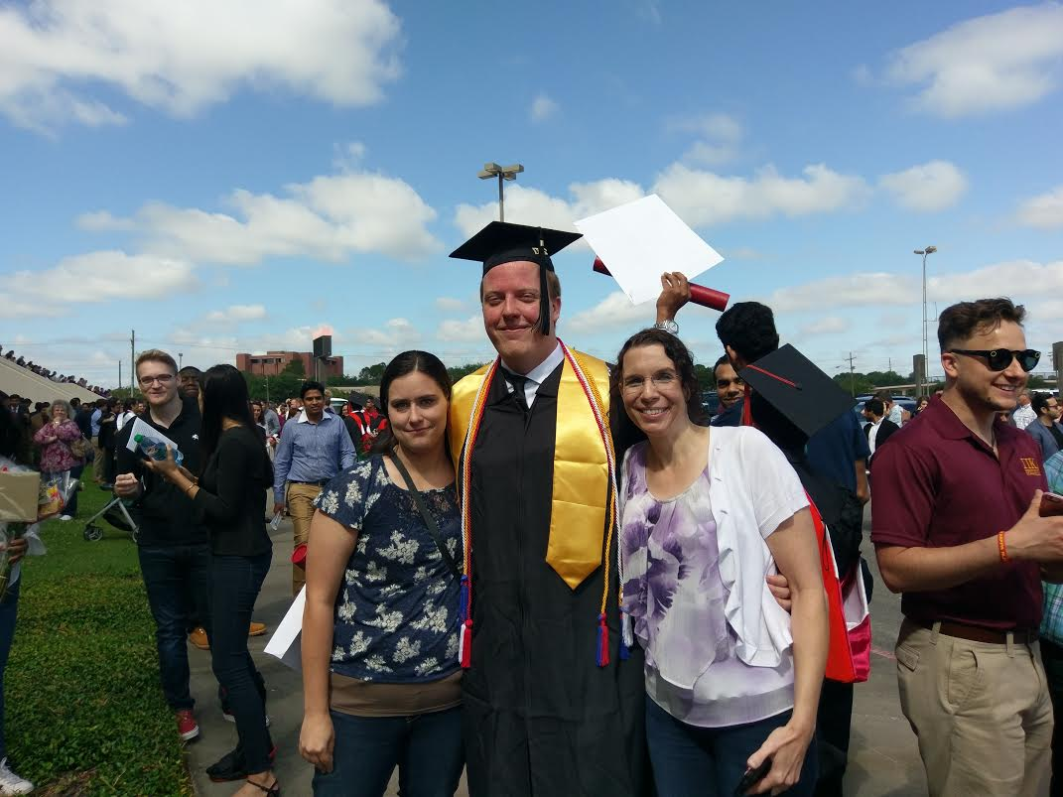
Figure 23: John Pickren (center) pictured with Suzanne Wheeler (left) and Kristina Moffett (right)
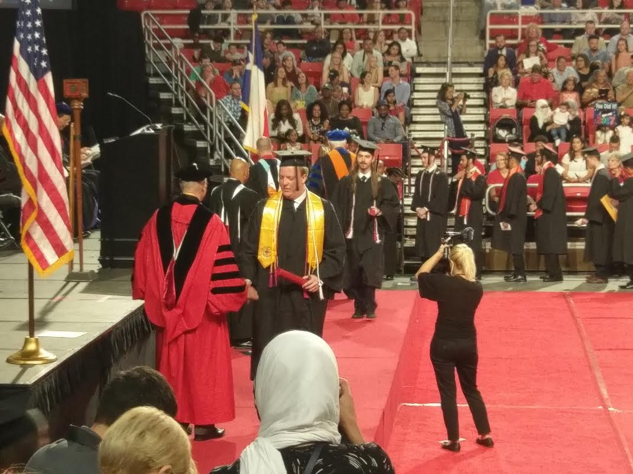
Figure 24: John Pickren (front) and Jonathan Taylor (back) walking at the Spring 2017 Lamar University graduation ceremony

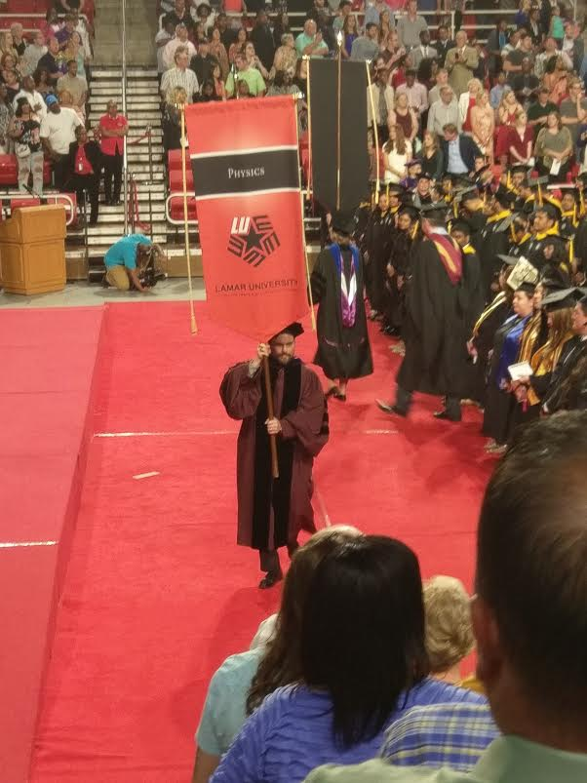
Figure 25: Dr. James Drachenberg bearing the physics flag at the Spring 2017 Lamar University graduation ceremony
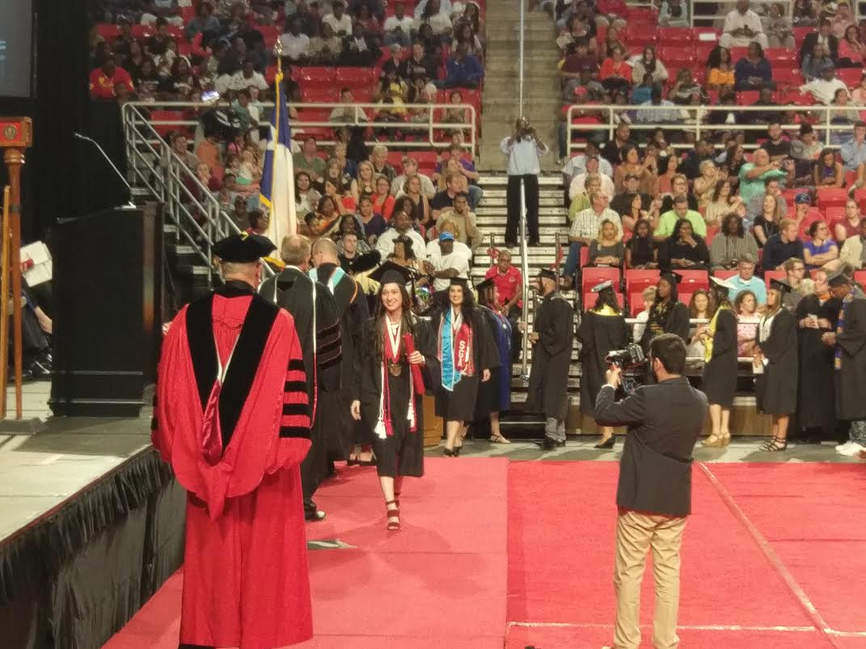
Figure 26: Jamie Stafford walking at the Spring 2017 Lamar University graduation ceremony

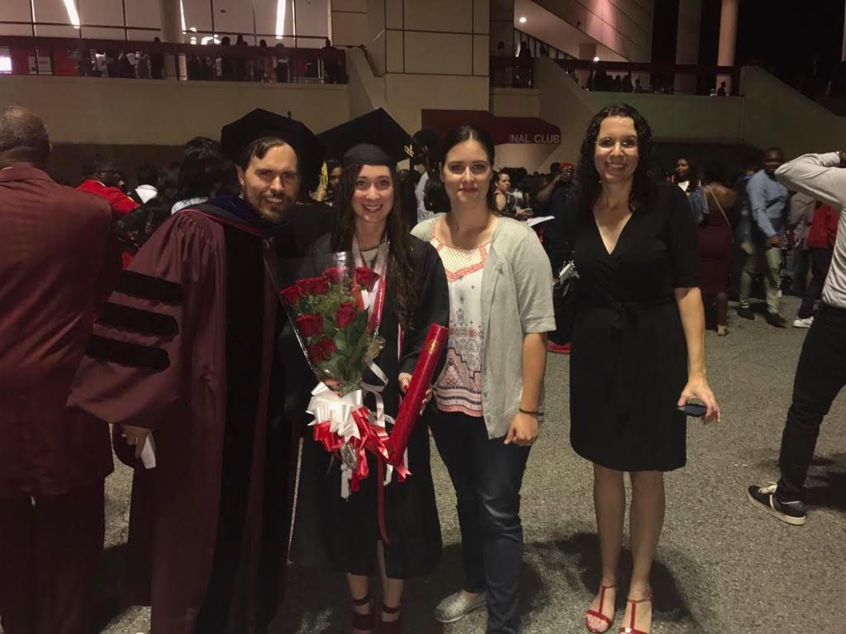
Figure 27: Jamie Stafford (center left) standing with Dr. James Drachenberg (far left), Suzanne Wheeler (center right) and Kristina Moffett (far right)

