Part 1: Our chapter’s interactions and participation in SPS National Programs.
Did your chapter vote in the 2016 SPS National Council election? Yes No

Participation in SPS National Programs
- For the second time in three years, the SPS chapter at Lamar University was awarded “Outstanding Chapter” for the 2015-2016 school year.
- Our SPS Chapter was awarded a Chapter Research Award for the 2016 calendar year. The title of the project is “Finding the Shape of a Glowing Object from Polarimetric Measurements [1].” The main set-up of the project is shown in Figure 2. Five SPS members have been involved with the project so far: Keeley Townley-Smith, Suzanne Wheeler, Azam Nurul, Mark Worth, and John Pickren (Figure 1). The results of the work were presented by Keeley Fairchild (Townley- Smith) at the Joint Spring 2016 Meeting of the Texas Sections of APS, AAPT, and Zone 13 of SPS hosted by Lamar Univ. between March 31- April 2, 2016 as a talk in the SPS section. Suzanne Wheeler had poster presentations at the Texas STEM conference in October 2016, PhysCON in November 2016, and a talk at CUWiP at Rice University in January 2017.
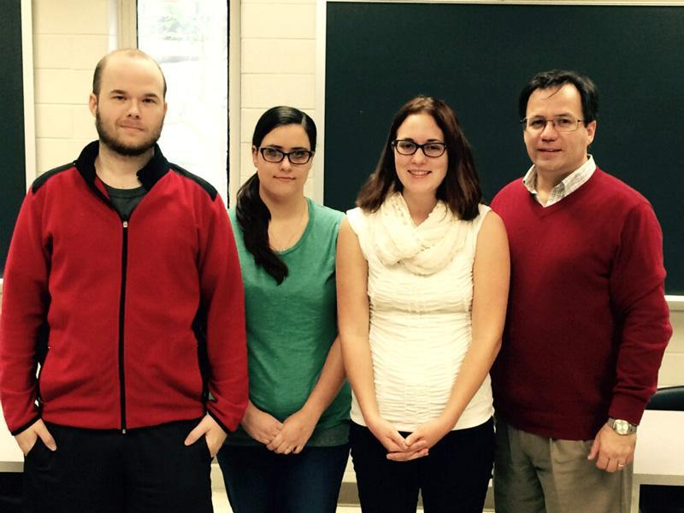
Figure 1: (From left to right) Mark Worth, Suzanne Wheeler, Keeley Townley-Smith, and Dr. Cristian Bahrim who authored the original proposal submitted to SPS in November 2015.
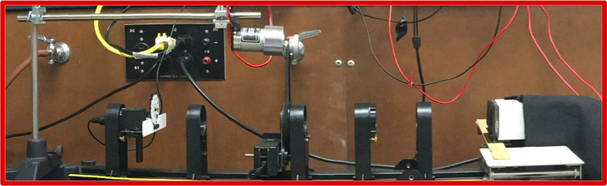
Figure 2: An improved setup of our polarization experiment to assess the shape of a glowing object. The setup was built with parts purchased with SPS finds from the 2016 Chapter Research Award.

- In Spring 2017, Zakary Noel, incoming SPS Vice President, applied for an SPS national internship program position and was accepted to the 10-week opportunity in Washington, D.C. A short article was written on the Lamar University news page and Noel recognized both the local and national SPS institutions in thanks for allowing him to participate in such an activity [2] [3].
- March 2017 - White Marsh Award for Outreach to high-schools in our Golden Triangle
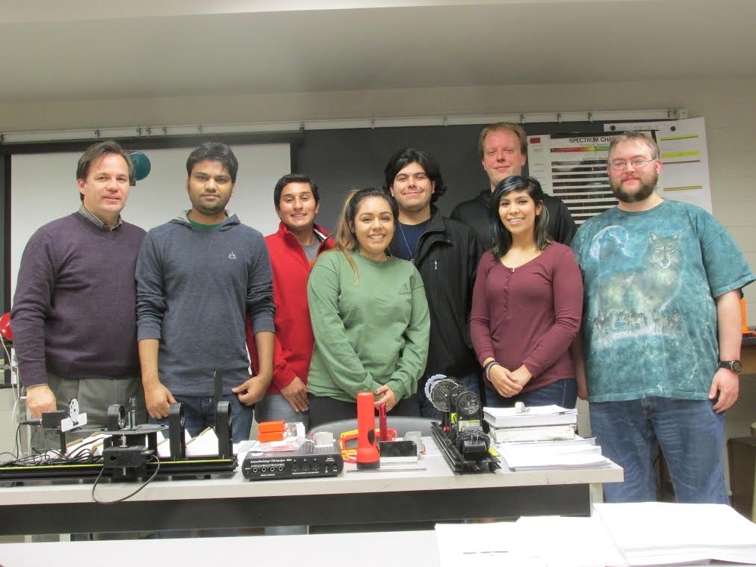
Figure 3: The group involved in the White Marsh Award (From left to right): Dr. Cristian, Azam Nurul, Carlos Caballero, Melanie Olvera, Zakary Noel, John Prickren, Gabrianna Escamilla, and Daniel Dove

Participation in SPS Governance
- In Spring 2016, Jamie Stafford, our outgoing SPS treasurer ran for the Associate Zone Councilor position. Keeley Townley-Smith ran for the same position in previous years.

