Part 4: Our chapter’s interaction with the off-campus public community

- In June 2016, the SPS chapter of Lamar University created a fundraiser of a merit badge camp through the Boy Scouts of America. SPS members John Pickren, Suzanne Wheeler, Zakary Noel, and Gabrianna Escamilla were a part of the planning process. We sought to teach the science-related and more technical merit badges that other normal counselors might not know about. The merit badge classes involved were Engineering, Electronics, Nuclear Science, and Astronomy. For the Engineering merit badge, we had the Lamar University Chair of Electrical Engineering, Dr. Harley Myler, create a short lecture. Electronics was jointly taught by Suzanne Wheeler and John Pickren. Astronomy was taught by the Lamar University physics lab coordinator, Justin McCollum. Nuclear Science was taught by John Pickren. It was a very successfully done fundraiser and all of the parents, scouts, and leaders had positive feedback for what we had put together. We hope that this will be a continuing tradition between our SPS chapter and the local Boy Scout community.

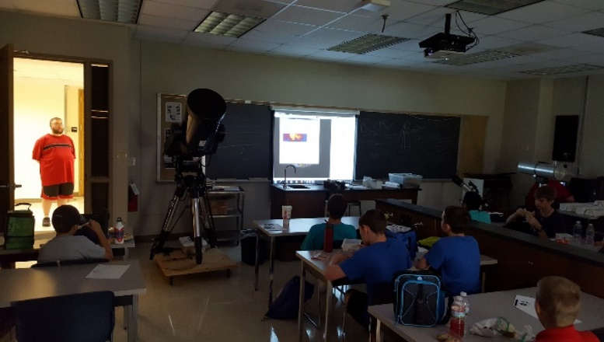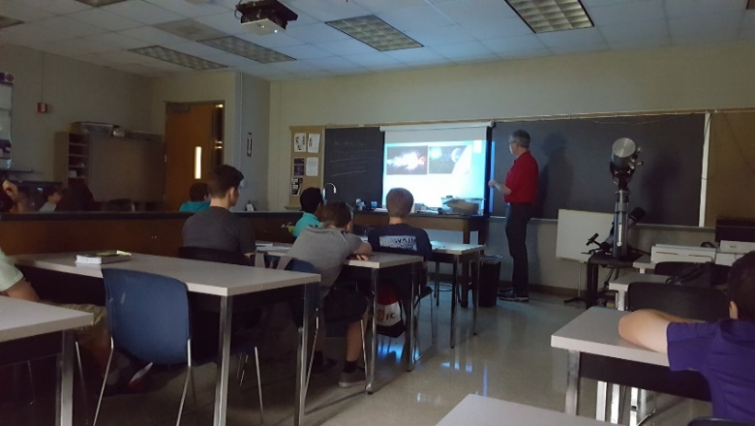
Figure 59: Boy Scouts attending the Astronomy merit badge class.

- Many of our SPS members were involved in the Youth Career EXPO that was organized at Ford Park by the Work Force Solutions of Southeast Texas in October 2016. This expo allowed us to create a booth to demonstrate some of the physics principles and experiments we use. Approximately 2000 high school students visited our booth. Suzanne Wheeler, Carlos Caballero, John Pickren, Azam Nurul, Zakary Noel, Gabrianna Escamilla, and SPS advisor Cristian Bahrim were all involved with this event.
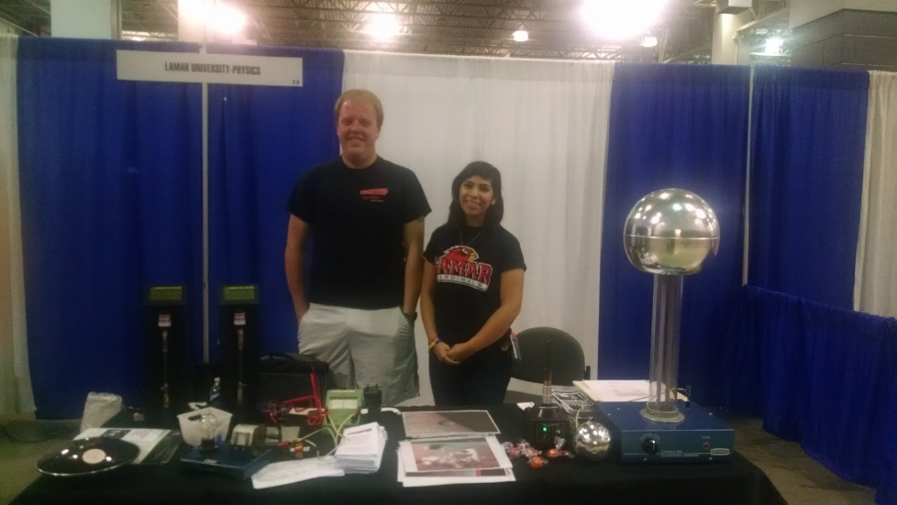
Figure 60: John Pickren and Gabbie Escamilla at the Youth Career EXPO
- In early January 2017, Zakary Noel participated in a community day in Baytown, Texas with members of Lee college SPS. Lee SPS ran a booth giving out prizes for participants who played simple science trivia games, and ran an indoor inflatable planetarium on loan from the Houston Museum of Natural Science.
- On February 2nd, 2017, Zakary Noel joined with Lee College SPS to run physics demos for students at Bowie Elementary school in Baytown, Texas. There, he worked with Catherine Wood, Lee SPS Secretary, and Tom O’Kuma, distinguished member of the AAPT.
- On February 17, 2017, SPS faculty advisor Cristian Bahrim and student Zakary Noel attended Summer Creek High School to present to students a brief set of demos and a presentation of careers in physics and physical science. Dr. Bahrim talked personally with a Summer Creek faculty member to facilitate the visit of high school students to Lamar University in the future.
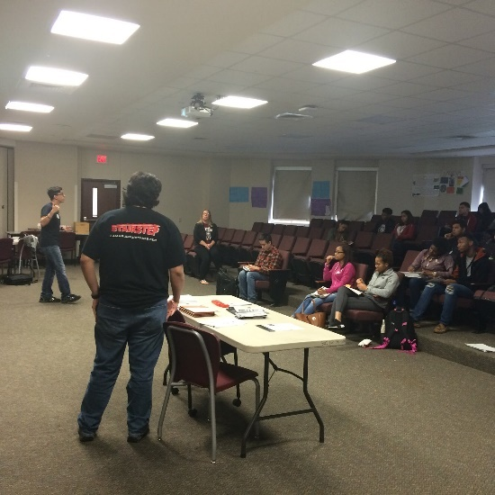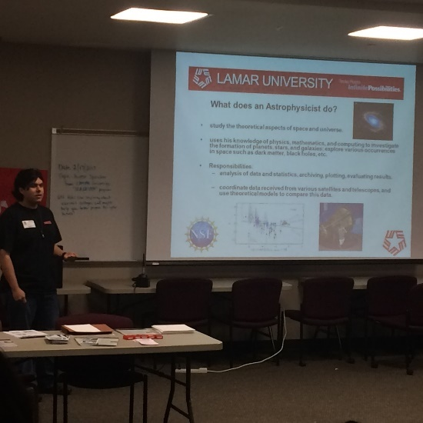
Figure 61: Zakary Noel and Dr. Cristian Bahrim (not pictured) presenting career opportunities at Summer Creek HS
- On February 18, 2017, Daniel Dove and Azam Nurul attended a mini-CAST in order to provide information about the Lamar University physics department and SPS chapter. They were soon joined by Dr. Bahrim who managed both this event as well as Cardinal View day that was held at Lamar.
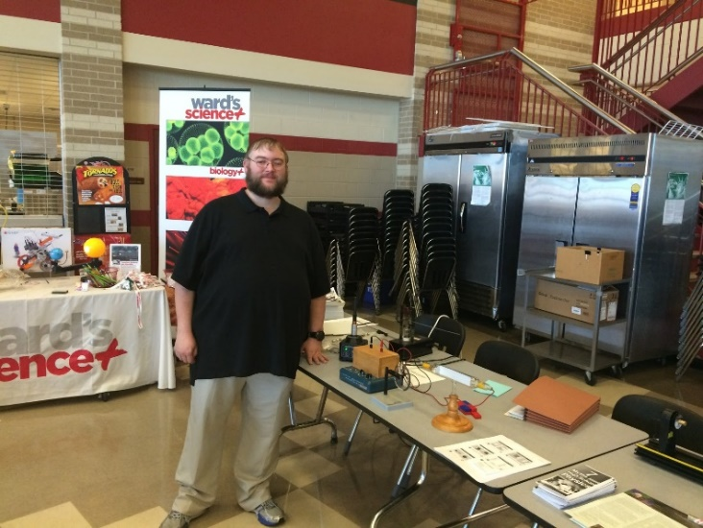
Figure 62: Daniel Dove at the mini-CAST event with a variety of physics demos
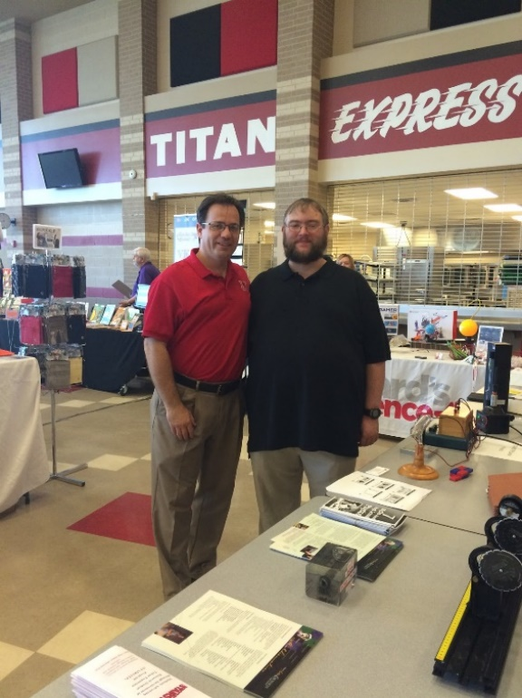
Figure 63: Dr. Cristian Bahrim (left) with Daniel Dove (right) at the mini-CAST event.
- In April 2017, Ozen High School hosted their mathematics honor society induction. Suzanne Wheeler, Carlos Caballero, and Zakary Noel showed posters of their research to the students so they could see what university level research looks like.
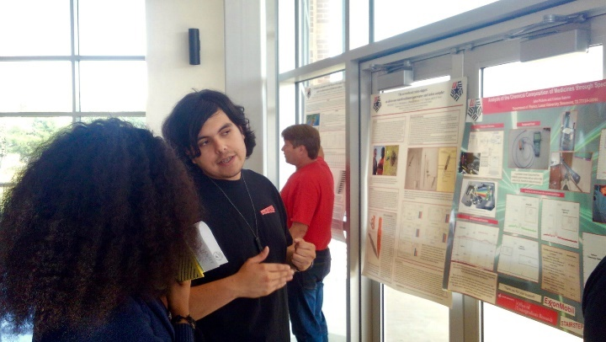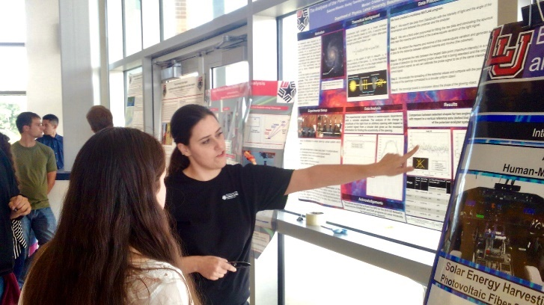
Figure 64: Zakary Noel and Suzanne Wheeler presenting their posters to students.
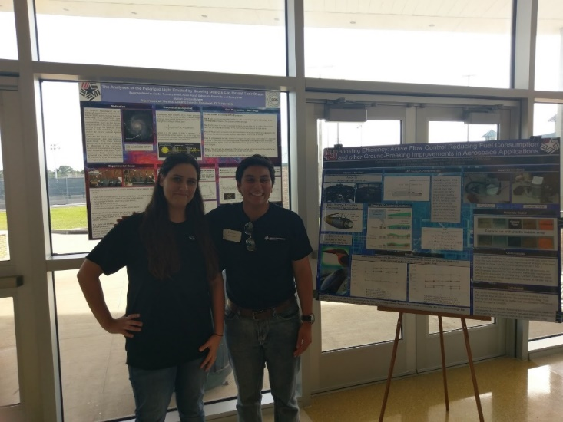
Figure 65: Suzanne Wheeler and Carlos Caballero pose in front of their posters.

- In May 2017, Suzanne Wheeler visited Memorial High School (her alma mater) to speak with mathematics students about college life and what you can do with a physics and mathematics degree. This event was done in collaboration with the STAIRSTEP program at Lamar.
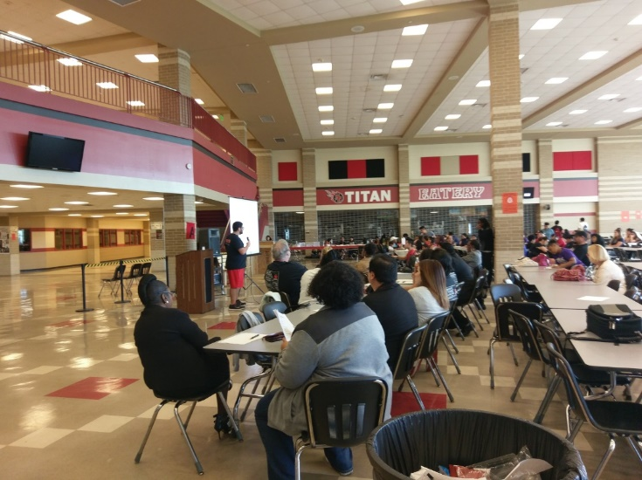
Figure 66: Johnathan Hodges (mathematics STAIRSTEP student) speaking to the group of parents and students.
- In June 2017, two SPS members, Gabbie Escamilla and Carlos Caballero participated in study abroad in Spain for engineering. During the trip Carlos was asked how the trip added to his knowledge about engineering, he said “It showed that engineering is much more than a set of rules and equations (which yes have their place and are important); there is the economic side and, perhaps, most importantly a people side. Above all, I believe engineers are problem solvers and this trip helped to hone in on those skills. We were presented with a challenge both directly (the class project) and at large with being inserted into a new, unknown environment and having to figure things out.”

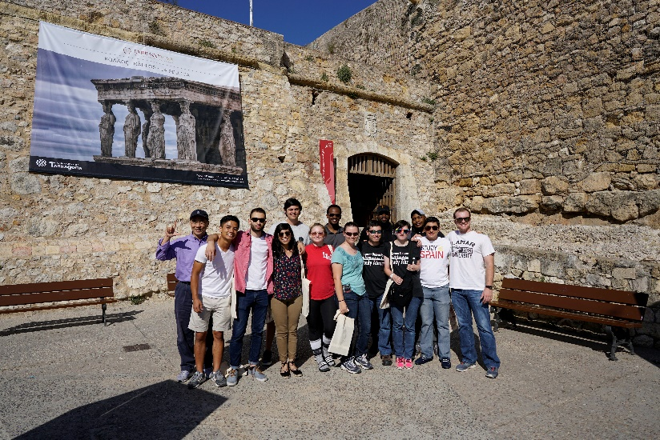
Figure 67: Gabbie (fourth from left) and Carlos (second from right) with the other study abroad students in Spain.
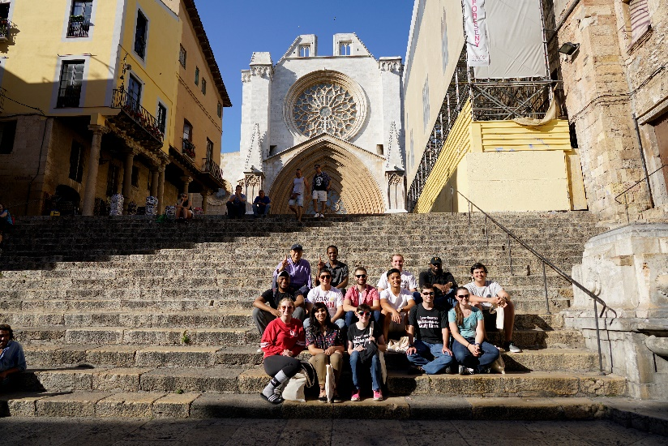
Figure 68: Study abroad students in Spain.

