Part 3: Our Chapter’s interactions with the professional physics community outside the college/university
- Jamie Stafford gave an oral presentation at the Gulf Coast Undergraduate Research Symposium (GCURS) hosted by Rice University in October 2016. Her talk was entitled: “Resonant Charge Transfer in Ion-Surface Interactions.”

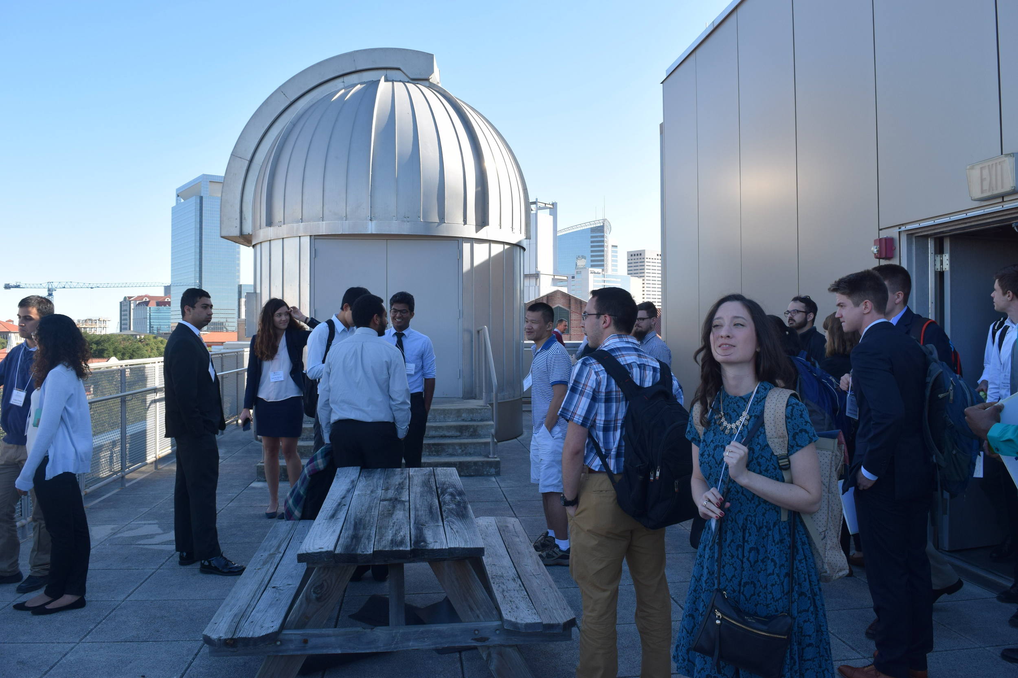
Figure 1: Jamie Stafford outside the observatory at Rice University.
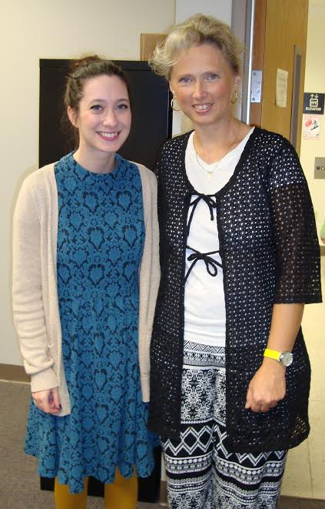
Figure 3.1: Jamie Stafford with her mentor, Dr. Bogdana Bahrim.
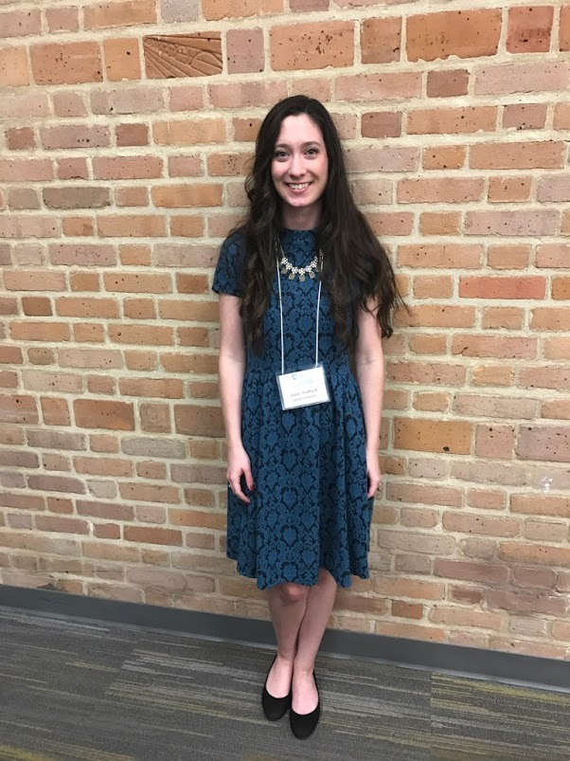
Figure 2: Jamie Stafford at Rice University for GCURS.
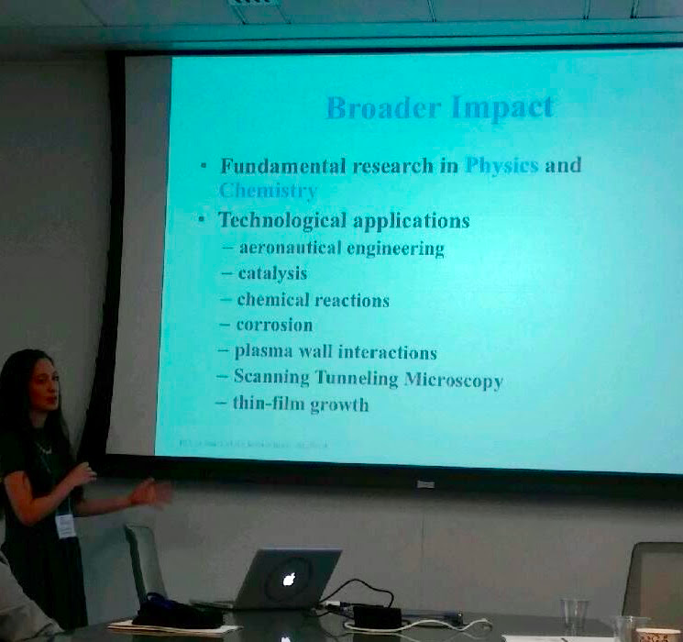
Figure 3: Jamie Stafford presenting her research at GCURS.
- During October 20-22, 2016, one SPS member attended the Joint Meeting of the Four Corners and Texas Sections of the American Physical Society
  - Attendees were: Azam Nurul and SPS advisor Dr. Cristian Bahrim.
  - Dr. Bahrim gave a talk about “A photonic switching mechanism using polarized light incident on dielectric surfaces,” in the Optics session [6].
- Jamie Stafford and Suzanne Wheeler presented at the Conference for Undergraduate Women in Physics 2017 at Rice University. Jamie’s talk was entitled: “Electron Dynamics in H/H− Collisions with Copper Surfaces [7]”
- Suzanne’s talk was entitled: “Finding the Shape of Glowing Openings by Filtering Light with Polarizers [8]”

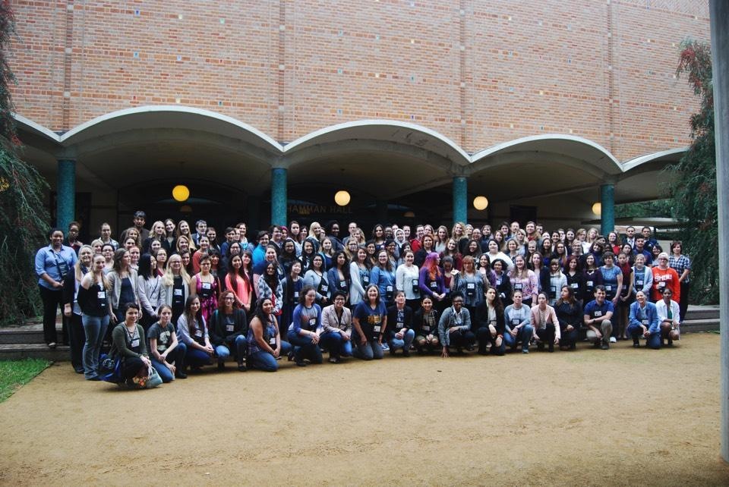
Figure 4: Group picture from CUWiP at Rice University.

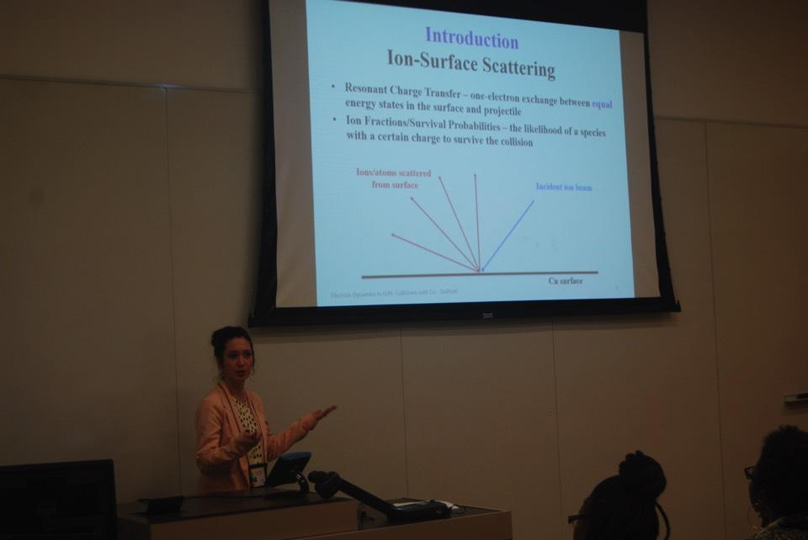
Figure 5: Jamie Stafford presenting her research at CUWiP at Rice.
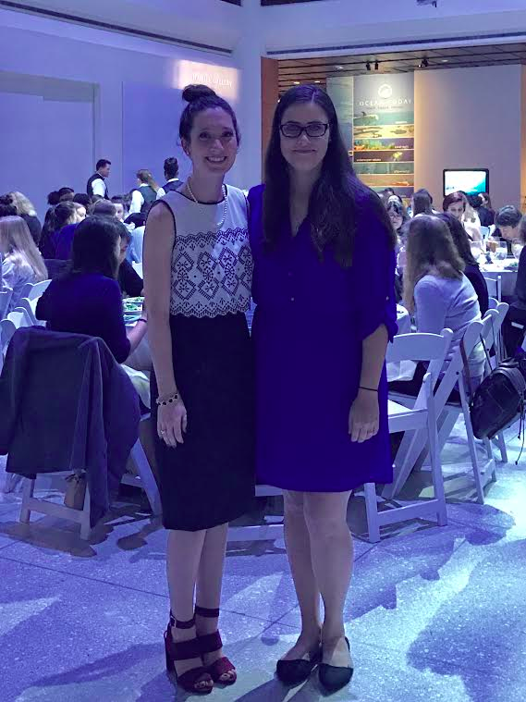
Figure 6: Jamie Stafford and Suzanne Wheeler at the banquet for CUWiP at Rice.

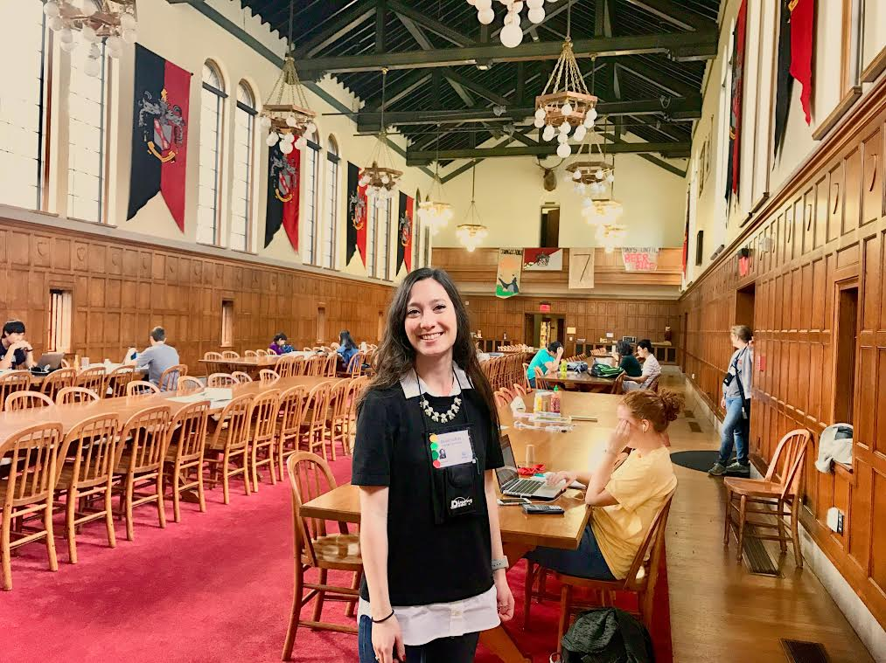
Figure 7: Jamie Stafford in “Harry Potter Hall” at Rice.
- Carlos Caballero’s paper "Saving fuel: Improving Aircraft Efficiency with Active Flow Control Systems and other Noble Ways to Save Energy," was selected for presentation at NCUR 30 at the University of North Carolina, Asheville. From the email sent by the organizers of NCUR 30 “Chosen from more than 4,000 submissions, your abstract demonstrates a unique contribution to your field of study, and we are glad to offer you the opportunity to present your work to your peers, faculty, and staff from all over the nation.”
- In Spring 2017, Zakary Noel attended the joint meeting of the Texas section AAPT, APS, and SPS zone 13 at the University of Texas at San Antonio to give a presentation at the SPS undergraduate research section of the conference, chaired by Courtney Lemon of SPS and AIP. The presentation was entitled, “Determining the Shape of Glowing Objects: Applications to Supernovae [9]” and the speaker recognized the grant funding from the SPS national office that made the project possible after his presentation.
  - Also at the Spring 2017 meeting, Noel attended an SPS-led workshop designed to show participants how to create simple demos using copper wire, batteries, magnets, and the principles of induced currents. At this workshop, he collaborated with SPS members from other universities as well as key SPS national figures such as James Merrick.

Brookhaven National Laboratory (BNL)
- As part of her McNair project, Dr. Jim Drachenberg brought Suzanne Wheeler to BNL in Long Island, New York for the STAR (Solenoidal Tracker at RHIC (Relativistic Heavy Ion Collider)) Collaboration meeting in May 2017 [10]. Suzanne was one a just a few undergraduates who attended the collaboration meeting.

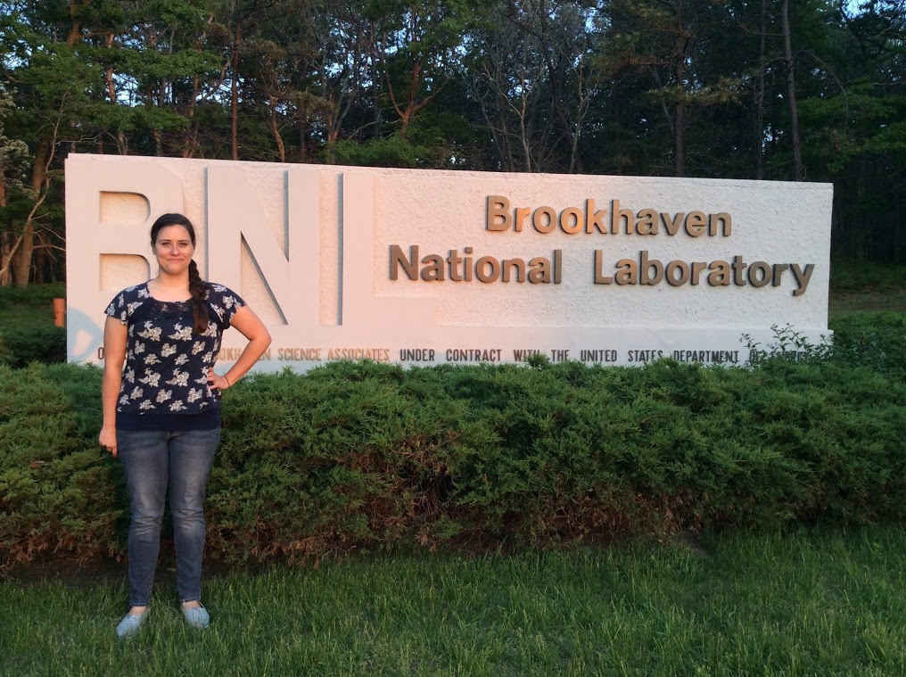
Figure 8: Suzanne Wheeler in front of the Brookhaven National Laboratory sign.
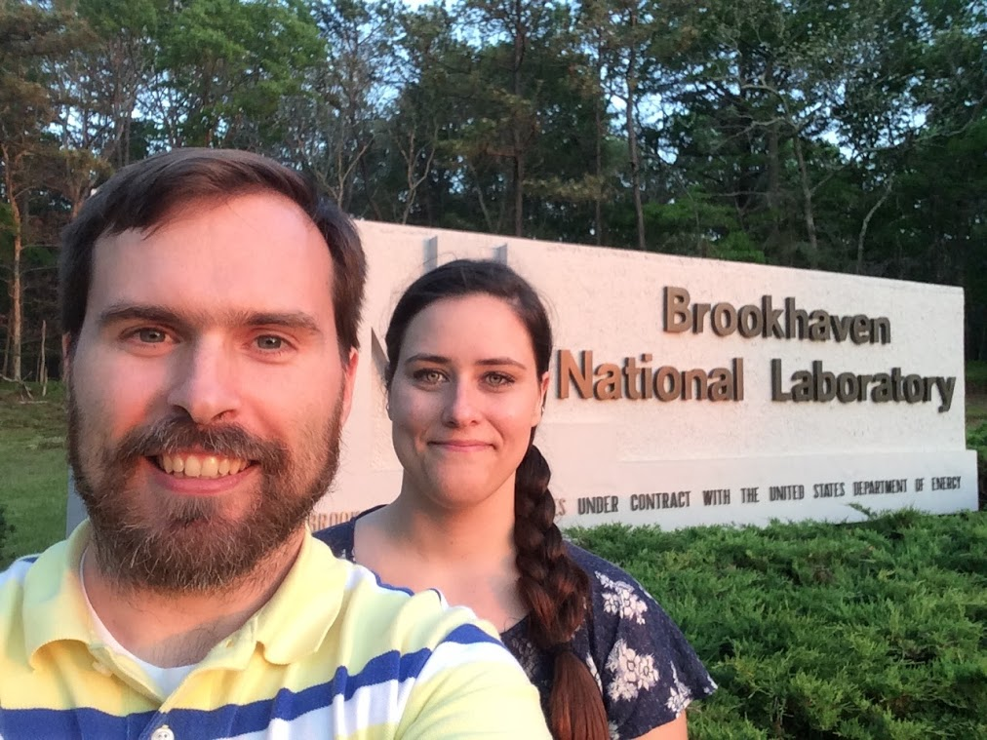
Figure 9: Dr. Drachenberg and Suzanne Wheeler in front of the Brookhaven National Laboratory Sign

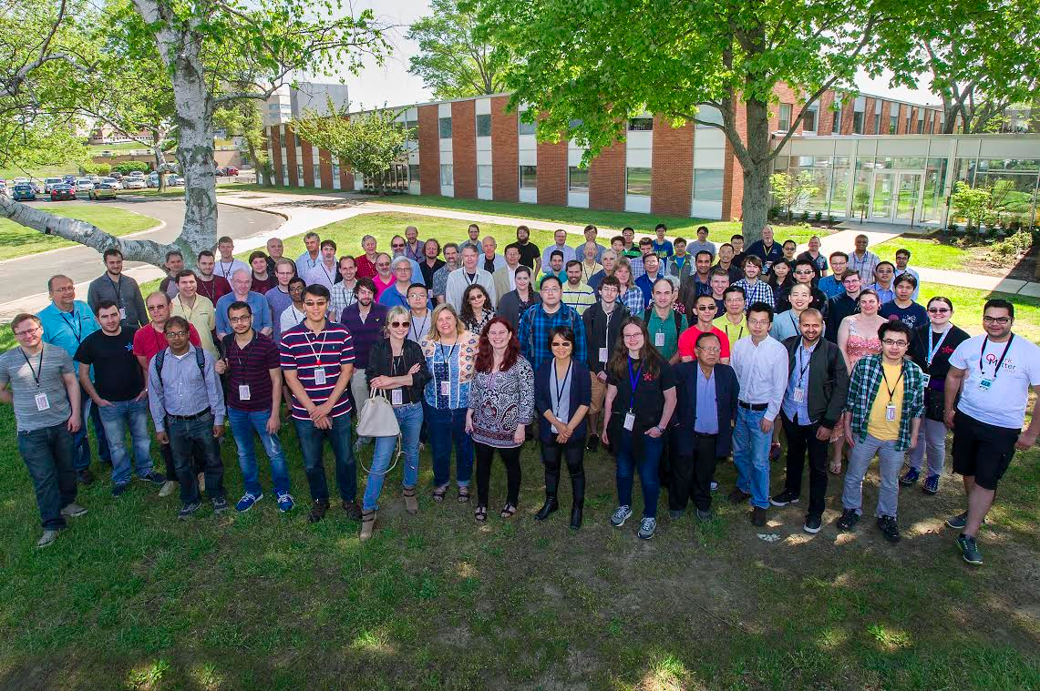
Figure 10: A group photo of the collaborators who attended the meeting .
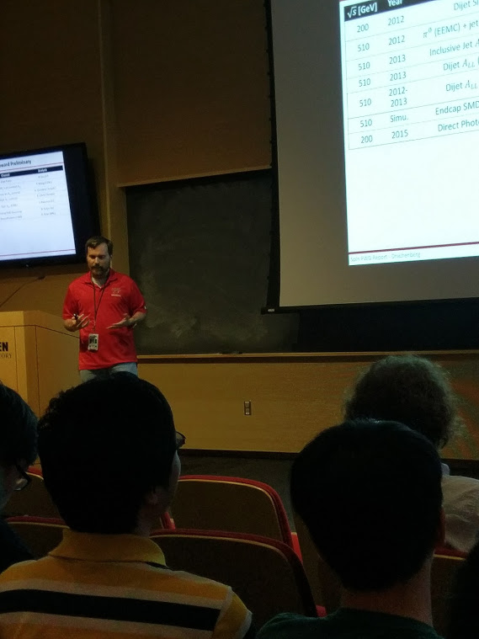
Figure 11: Dr. Drachenberg presenting at the collaboration meeting.
  - As part of their time at BNL, the STAR detector had an access day and Suzanne was able to see the detector in person for the first time after studying it for the past semester.

